
How to PRINT a business license from the City of Tarpon Springs Portal
Step 1: Go to City of Tarpon Springs Business Licenses
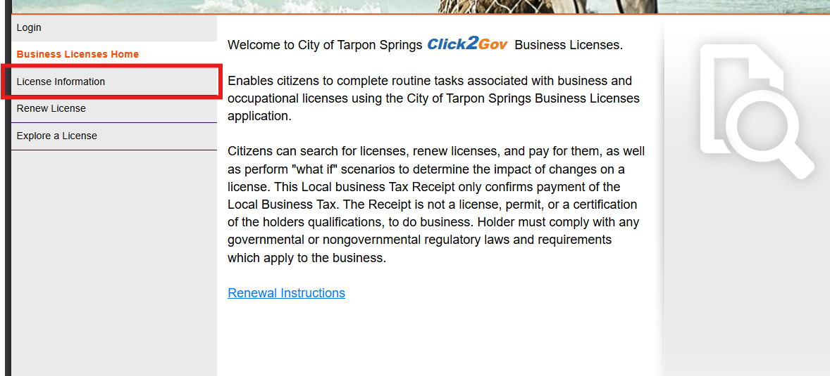
Step 2: Click “LICENSE INFORMATION “

Step 3: Select Search by: Business Name
Step 4: Type in your business name in the Search Criteria and click “Search”
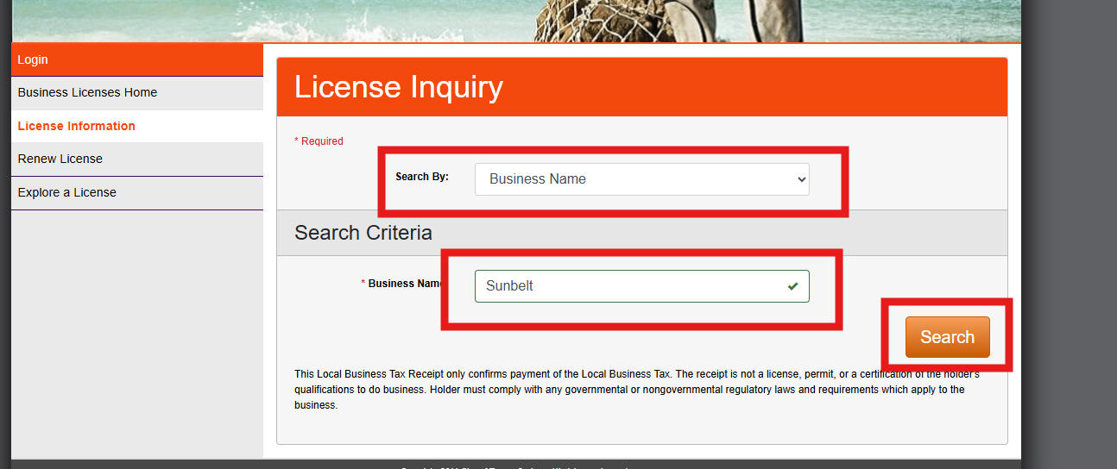
How to PRINT a business license from the City of Tarpon Springs Portal

Step 4: Find your Business Name and click the blue link under “Business Name”
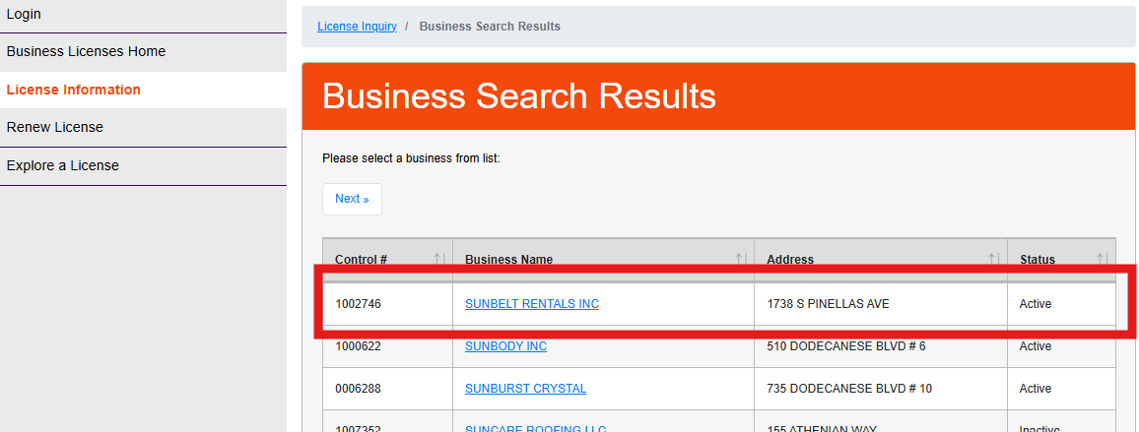

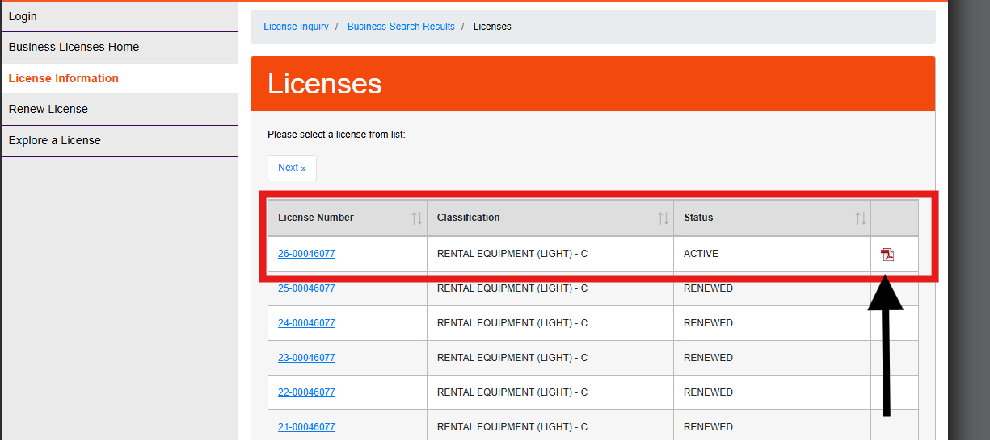
Step 5: If your license is up to date you can click the PDF Icon on the right hand side next to the “Status” column which will download a copy of your license to your computer which will allow you to save and print.

