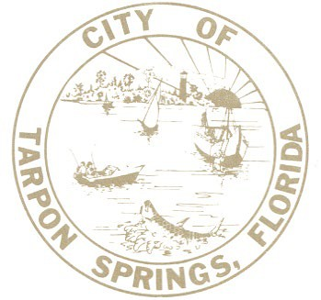

BUILDING DEVELOPMENT DEPARTMENT
City of Tarpon Springs, Florida
324 E. PINE STREET P.O. BOX 5004
TARPON SPRINGS, FL 34688-5004 (727) 942-5617
Email: dsinfo@ctsfl.us
www.ctsfl.us

BUILDING DEVELOPMENT PERSONNEL LICENSURE

David Gilson, CBO, CFM Building Development Director

Keith Meade, CFM Deputy Building Official Building Code Administrator Inspector: Residential; Coastal
Commercial Inspector: Building, Mechanical
Certified Storm Water Site Inspector Plans Examiner: Building & Residential Certified Floodplain Manager

Lisa Godwin, CFM Plans Examiner
Plans Examiner: Building
Certified Floodplain Manager

Shannon Brewer CFM Municipal Arborist
ISA Certified Arborist
ISA Certified Arborist Municipal Specialist ISA Tree Risk Assessment Qualification FNGLA Certified Horticulture Professional
Certified Level III Code Enforcement Officer
Certified Floodplain Manager
DEP Stormwater Management Inspector
OSHA Construction Safety & Health Certification
FDOT Maintenance of Traffic (MOT) Intermediate Certificate
FDACS LTD Commercial Fertilizer Applicator
Unmanned Aircraft System (UAS) Pilot

Allen Riggs
Building Development Inspector Inspector: Standard Plumbing
Inspector: Standard Mechanical

Ben Jensen
Building Development Inspector
Inspector: Building

TBD
Building Development Inspector

Christopher Brown
Construction Site Inspector

Tracey Norris
Building Development Permit Technician II

Jessica Hamrick
Building Development Permit Technician I

Andrew Nikiforakis
Building Development Permit Technician I

TBD
Building Development Permit Technician I

NOTE: All State Department of Business and Professional Regulation Certifications expire on November 30, 2023.

Rev. 9/19/23

