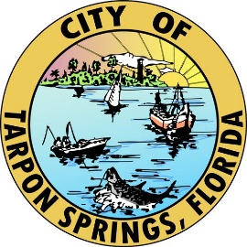

NOTICE OF CONSTRUCTION

The City of Tarpon Springs’ contractor, Kamminga & Roodvoets, is expected to start in the upcoming weeks, the Bayshore Septic to Sewer Conversion Project that will install a new Low Pressure Sanitary Sewer (LPSS) throughout the Bayshore neighborhood.

Construction is expected to last approximately 180 days from start to finish. Please be aware, traffic may be congested and workers will be in the roadway at times. Thank you for your patience and understanding.

If you have any questions please contact the City of Tarpon Springs Project Administration Dept. at 727-942-5638

https://www.ctsfl.us/project-administration/



NOTICE OF CONSTRUCTION

The City of Tarpon Springs’ contractor, Kamminga & Roodvoets, is expected to start in the upcoming weeks, the Bayshore Septic to Sewer Conversion Project that will install a new Low Pressure Sanitary Sewer (LPSS) throughout the Bayshore neighborhood.

Construction is expected to last approximately 180 days from start to finish. Please be aware, traffic may be congested and workers will be in the roadway at times. Thank you for your patience and understanding.

If you have any questions please contact the City of Tarpon Springs Project Administration Dept. at 727-942-5638.

https://www.ctsfl.us/project-administration/



NOTICE OF CONSTRUCTION

The City of Tarpon Springs’ contractor, Kamminga & Roodvoets, is expected to start in the upcoming weeks, the Bayshore Septic to Sewer Conversion Project that will install a new Low Pressure Sanitary Sewer (LPSS) throughout the Bayshore neighborhood.

Construction is expected to last approximately 180 days from start to finish. Please be aware, traffic may be congested and workers will be in the roadway at times. Thank you for your patience and understanding.

If you have any questions please contact the City of Tarpon Springs Project Administration Dept. at 727-942-5638.

https://www.ctsfl.us/project-administration/