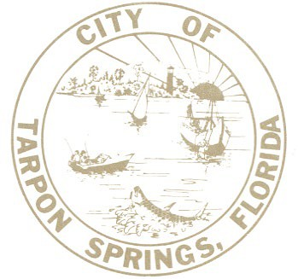

BUILDING DEVELOPMENT DEPARTMENT

City of Tarpon Springs, Florida

324 E. PINE STREET P.O. BOX 5004

TARPON SPRINGS, FL 34688-5004 (727) 942-5617

Email: dsinfo@ctsfl.us

[www.ctsfl.us](http://www.ctsfl.us/)

**BUILDING DEVELOPMENT PERSONNEL LICENSURE**

**David Gilson, CBO, CFM Building Development Director**

**Keith Meade, CFM Deputy Building Official** Building Code Administrator Inspector: Residential; Coastal

Commercial Inspector: Building, Mechanical

Certified Storm Water Site Inspector Plans Examiner: Building & Residential Certified Floodplain Manager

**Lisa Godwin, CFM Plans Examiner**

Plans Examiner: Building

Certified Floodplain Manager

**Shannon Brewer CFM Municipal Arborist**

ISA Certified Arborist

ISA Certified Arborist Municipal Specialist ISA Tree Risk Assessment Qualification FNGLA Certified Horticulture Professional

Certified Level III Code Enforcement Officer

Certified Floodplain Manager

DEP Stormwater Management Inspector

OSHA Construction Safety & Health Certification

FDOT Maintenance of Traffic (MOT) Intermediate Certificate

FDACS LTD Commercial Fertilizer Applicator

Unmanned Aircraft System (UAS) Pilot

**Allen Riggs**

**Building Development Inspector** Inspector: Standard Plumbing

Inspector: Standard Mechanical

**Ben Jensen**

**Building Development Inspector**

Inspector: Building

**TBD**

**Building Development Inspector**

**Christopher Brown**

**Construction Site Inspector**

**Tracey Norris**

**Building Development Permit Technician II**

**Jessica Hamrick**

**Building Development Permit Technician I**

**Andrew Nikiforakis**

**Building Development Permit Technician I**

**TBD**

**Building Development Permit Technician I**

**NOTE: All State Department of Business and Professional Regulation Certifications expire on November 30, 2023.**

Rev. 9/19/23